



|  |  |  |
| --- | --- | --- |
| **Supervisor** | SIR SHAHRYAR | |
| **Batch** | 2208C2 | |
| **Group** | **A** | |
| **Serial No.** | **Enrollment Number** | **Student Name** |
| 1. | Student1417942 | HUDA |
| 2. | Student1411205 | PAKEEZA |
| 3. | Student1417919 | OWAIS ALAM |
| 4. | Student1411204 | AMMAR IRFAN KOTWAL |

**Problem Statement:**

Music and Video’s are the most common source of entertainment today.

SOUND Group wants to host a WEBSITE for Entertainment. Company is looking on hosting new and old Video’s and Songs in both REGIONAL and ENGLISH language.

WEBSITE should have proper menu structure and Music and Video should be arranged as per ALBUM, ARTIST, YEAR, GENRE, LANGUAGE etc.

Users should have option of reviewing and rating the Music and Video’s available.

Home Page should have information about the site and a section for latest music and video with 5-5 listing in each.

**Customer Specifications:**

Website will host information about songs and videos with images and description and “New” image/icon should flash along with the new additions to Music and Video’s.

The website will have three users/roles:

1. Administrator
2. USER

The Administrator should be able to do the following:

1. Add Music files with information.
2. Add Video files with information.
3. Create Categories viz. YEAR, ARTIST, ALBUM etc.
4. Delete Music files
5. Delete Video files.
6. Create/Manage Users/Logins
7. Manage information/details on the WEBSITE

The USER should be able to do the following:

1. Register/Create Account [USERID should be unique].
2. Search for MUSIC/Video based on Name, ARTIST, YEAR, ALBUM etc.
3. ADD/Modify Reviews
4. ADD/Modify Ratings

Note: Name, Address, Phone Numbers, Email-ids should be mandatory to be provided. Proper Validations should be applied on all Data Fields.

Project should be submitted along with proper documentation and Database Backup.

**Requirement Specification:**

SOUND Group wants to host a WEBSITE for Entertainment. Company is looking on hosting new and old Video’s and Songs in both REGIONAL and ENGLISH language.

WEBSITE should have proper menu structure and Music and Video should be arranged as per ALBUM, ARTIST, YEAR, GENRE, LANGUAGE etc.

Users should have option of reviewing and rating the Music and Video’s available.

Home Page should have information about the site and a section for latest music and video with 5-5 listing in each.

Website will host information about songs and videos with images and description and “New” image/icon should flash along with the new additions to Music and Video’s.

The website will have three users/roles:

1. Administrator
2. USER

The Administrator should be able to do the following:

1. Add Music files with information.
2. Add Video files with information.
3. Create Categories viz. YEAR, ARTIST, ALBUM etc.
4. Delete Music files
5. Delete Video files.
6. Create/Manage Users/Logins
7. Manage information/details on the WEBSITE

The USER should be able to do the following:

1. Register/Create Account [USERID should be unique].
2. Search for MUSIC/Video based on Name, ARTIST, YEAR, ALBUM etc.
3. ADD/Modify Reviews
4. ADD/Modify Ratings

Note: Name, Address, Phone Numbers, Email-ids should be mandatory to be provided. Proper Validations should be applied on all Data Fields.

Project should be submitted along with proper documentation and Database Backup.

**ACKNOWLEDGEMENT:**

We would like to express our heartfelt gratitude to the dynamic and vibrant PHP community, whose contributions have added a harmonious rhythm to the backend of our website. Just as music brings life to melodies, PHP has breathed life into the functionality and interactivity of our platform.

We extend our thanks to the creators and maintainers of PHP, whose dedication and expertise have crafted a versatile language that resonates with developers around the world. Your commitment to continuous improvement has kept PHP in tune with the evolving demands of the digital landscape.

**SYNOPSIS:**

In the realm of web development, where functionality and interactivity merge seamlessly, the role of PHP resonates as a harmonious symphony, akin to the sounds, music, and songs that enrich our lives. This synopsis delves into the intriguing synergy between PHP and auditory elements, exploring how they come together to compose an engaging and immersive backend experience for websites.

Introduction:

The digital landscape is ever-evolving, demanding websites to not only function flawlessly but also captivate users with engaging experiences. Just as music has the power to evoke emotions and create memories, PHP - a versatile scripting language - lends its melody to the intricate backend operations of websites. This synthesis of technology and artistry creates a unique symphony that enhances user engagement.

PHP as the Composer:

PHP, known for its flexibility and adaptability, takes on the role of a composer in the digital orchestra. Its code orchestrates the various components of a website's backend, guiding data manipulation, interactions, and transactions. Just as a composer arranges notes to create harmonies, PHP strings together code snippets to generate harmonious functionality.

Conclusion:

In the ever-evolving world of web development, PHP's role in crafting the backend of websites is akin to composing a symphony. The incorporation of auditory elements further enriches the user experience, creating a multisensory journey that resonates with visitors. As technology and artistry continue to harmonize, the symphony of PHP, sounds, music, and songs forms an enchanting backdrop to the digital stage, captivating users and enhancing their interactions.

**WIREFRAMES**

**WEBSITE Navbar:**

**ADMIN Navbar:**

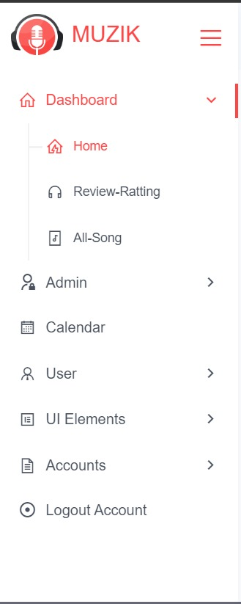

**Carousel:**

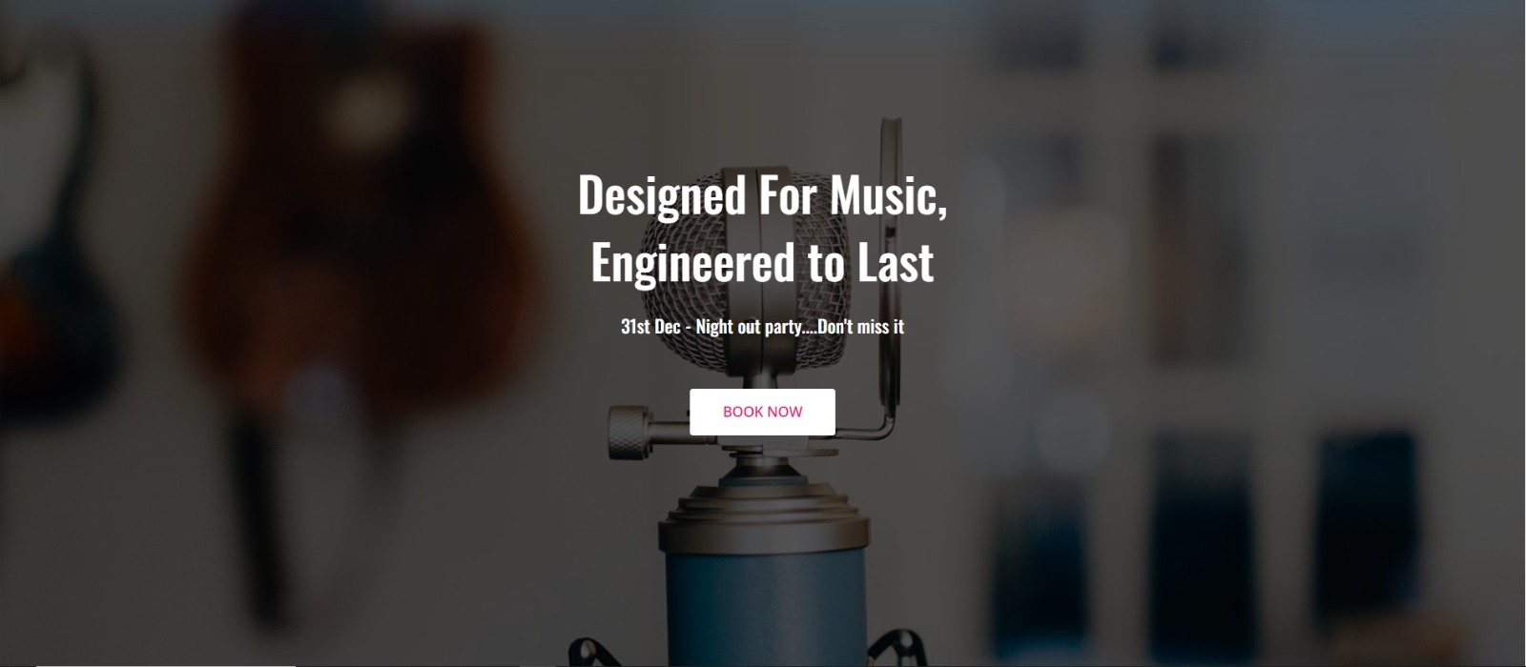

**ALBUM LIST:**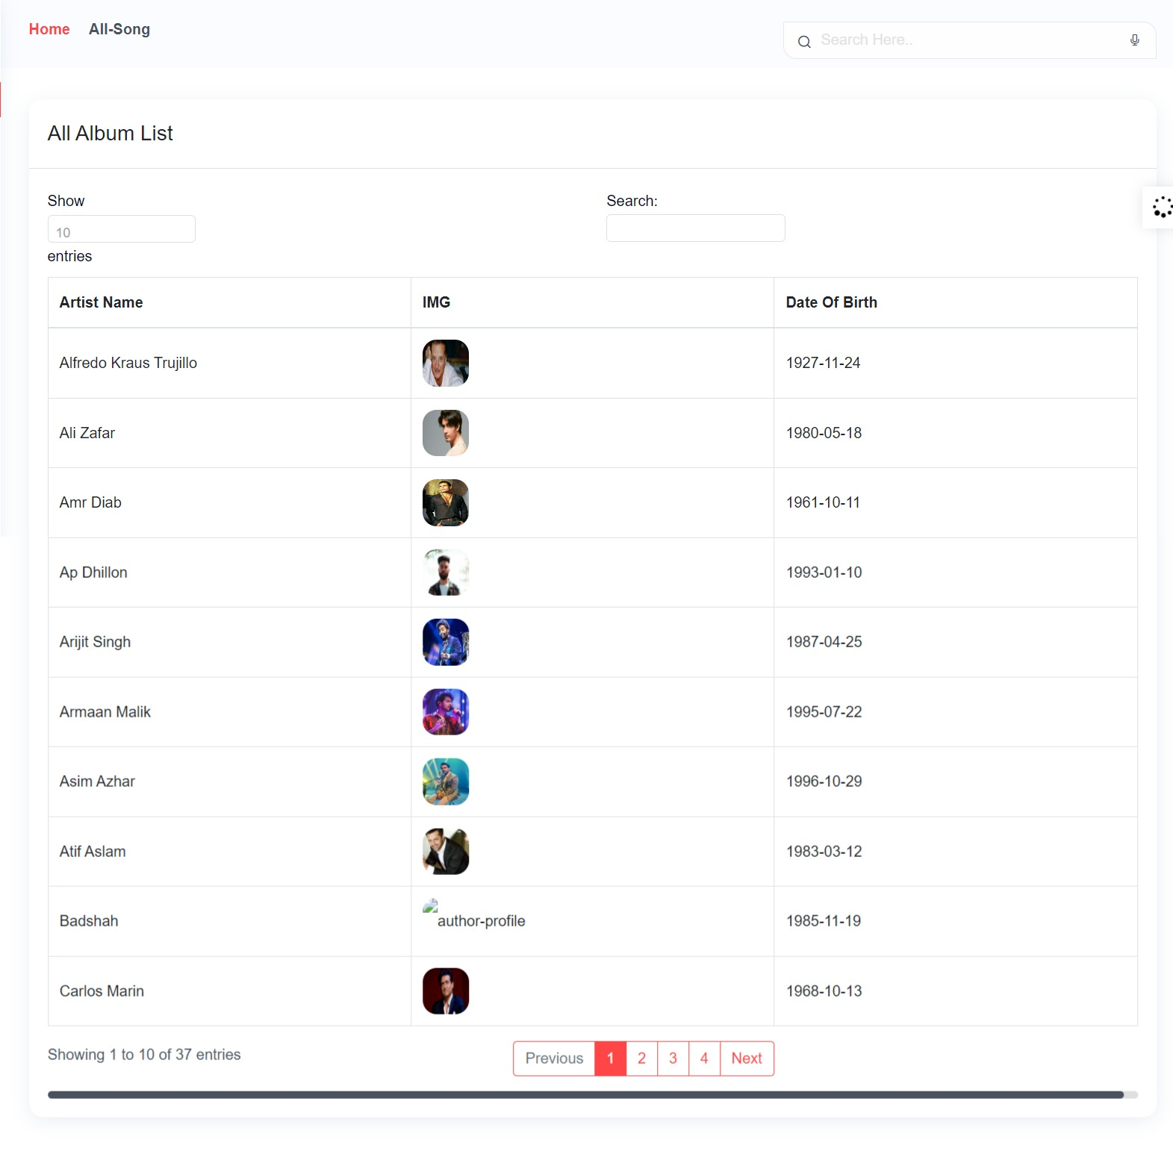

**SINGERS LIST:**

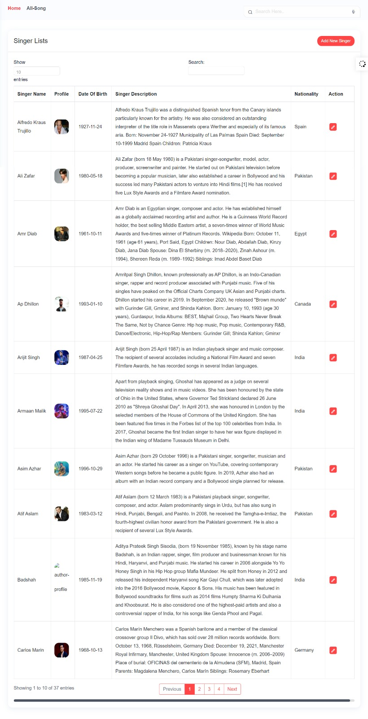

**SONGS LIST:**

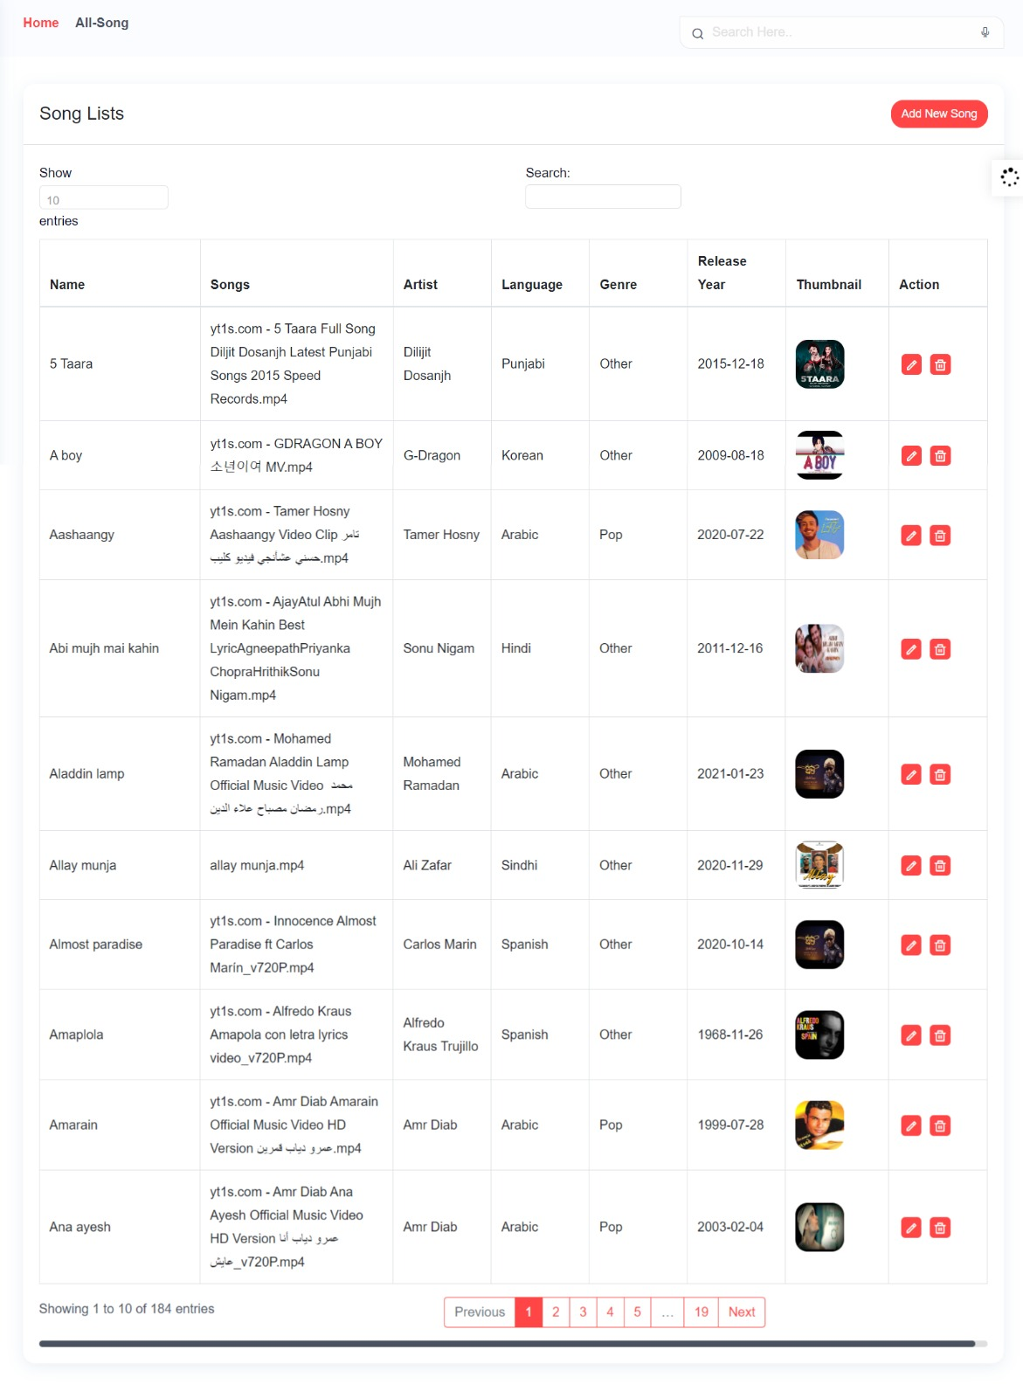

**OST LIST:**

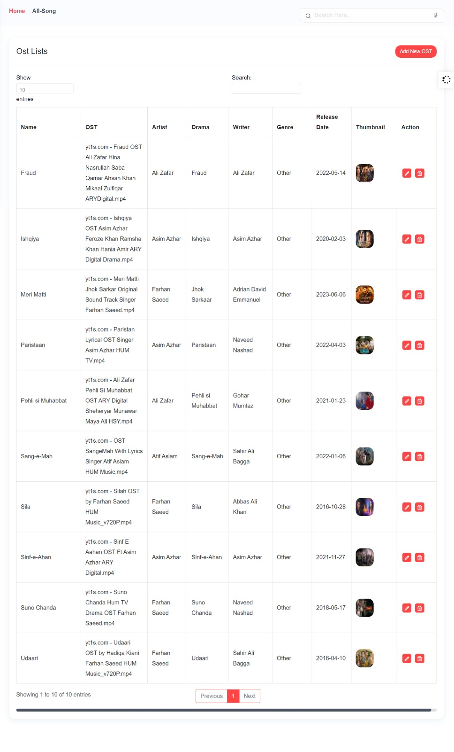

**BLOGS:**

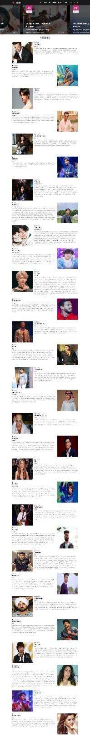

**LOGIN SIGNUP FOR USER:**

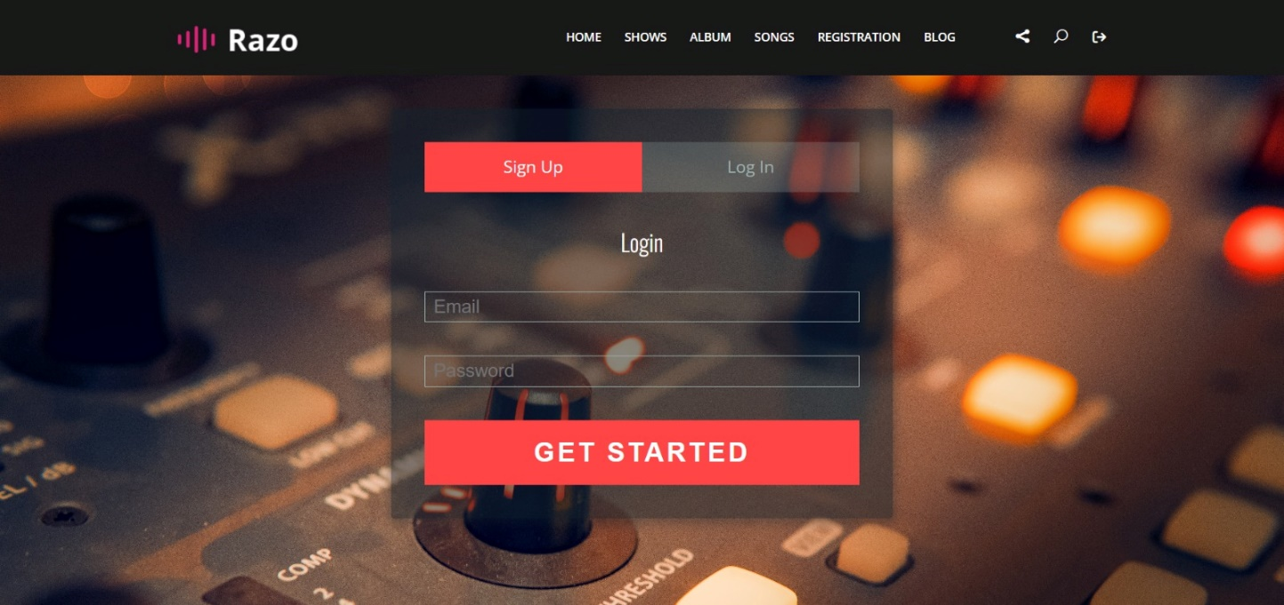

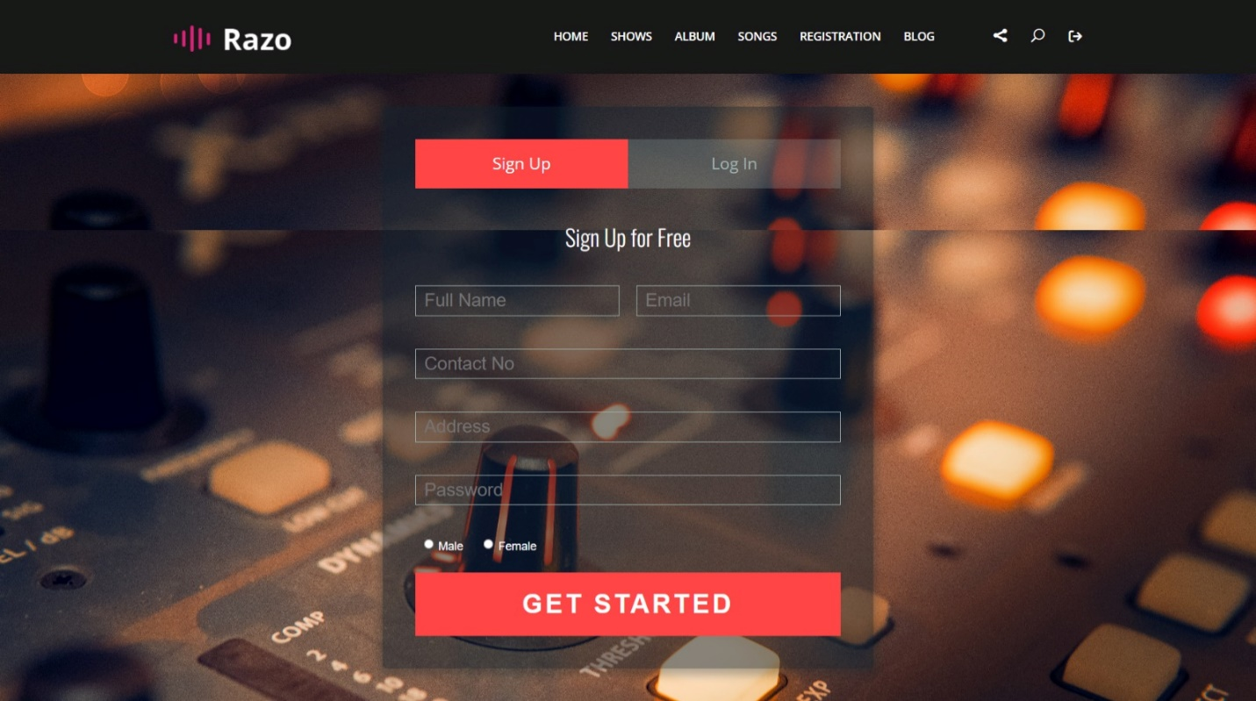

**REGISTRATION FOR ADMIN:**

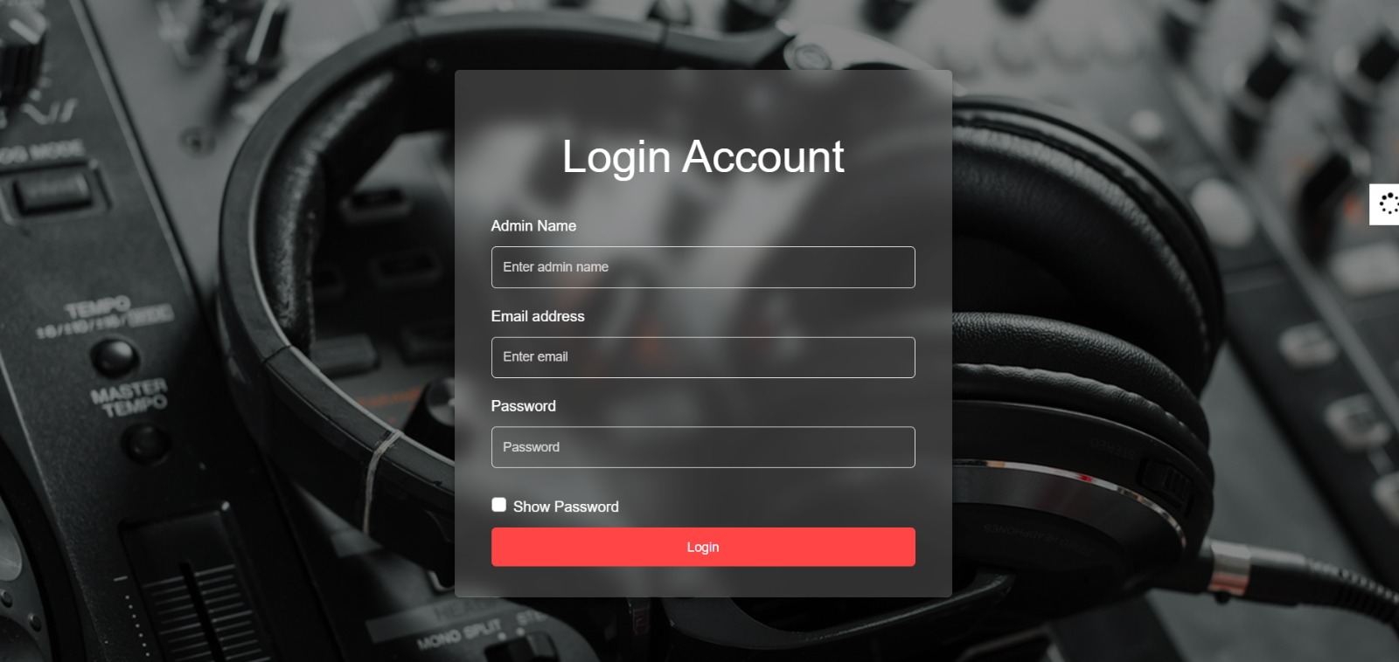

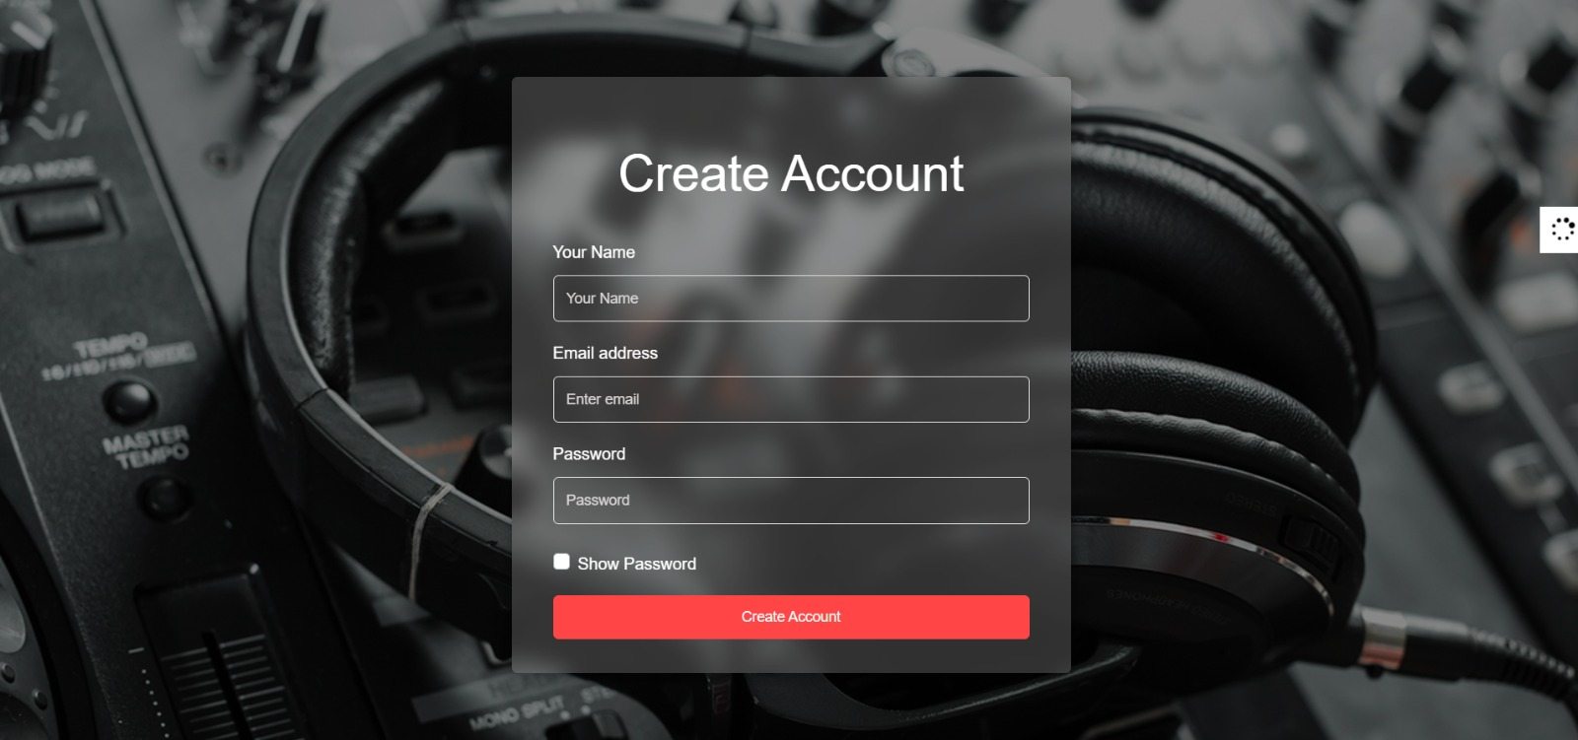

**FOOTER:**

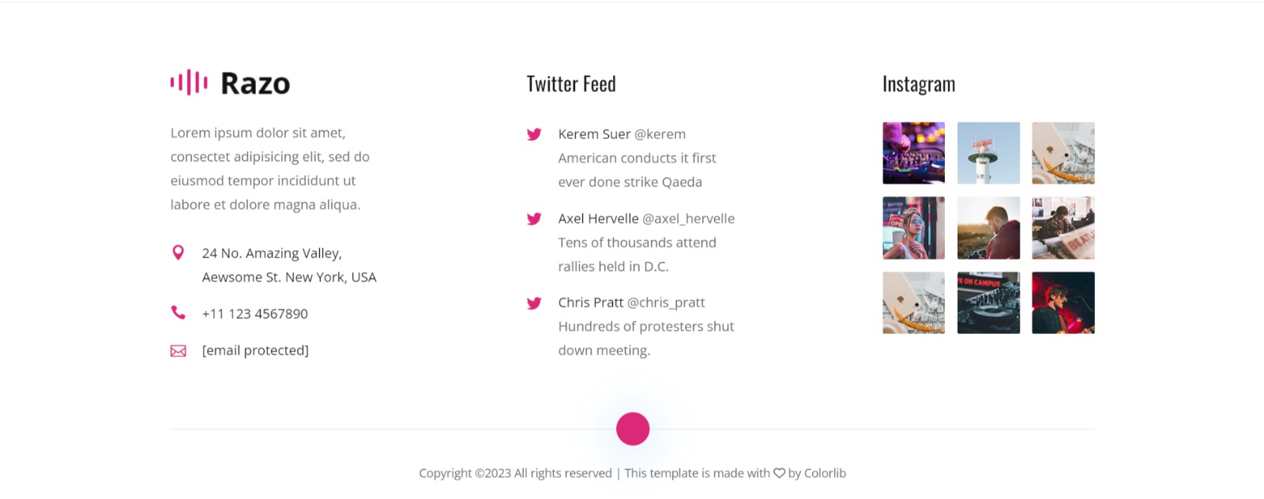

**Task Sheet Review**

|  |  |  |  |  |  |  |
| --- | --- | --- | --- | --- | --- | --- |
| No. | **Task** |  | Actual | Actual | Name | Status |
| Start date | Days |
| 1 | Build Dashboard Charts & Database | PHP Sound | 10/July/23 | 5 | Owais | Complete |
| 2 | Build Add Contents Forms | PHP Sound | 15/July/23 | 1 | Ammar | Complete |
| 3 | Build All Songs, OST & Album Pages | PHP Sound | 17/July/23 | 1 | Pakiza | Complete |
| 4 | Build an Update Review Ratings | PHP Sound | 19/July/23 | 7 | Owais | Complete |
| 5 | Build  Login page for both users & admin  Signup page for both users & admin | PHP Sound | 27/July/23 | 1 | Huda | Complete |
| 6 | Begin Code  JavaScript for  Home page and  Album page | PHP Sound | 29/July/23 | 2 | Ammar, Owais | Complete |
| 7 | Begin Code  Support For  Browsers and  content | PHP Sound | 1/Aug/23 | 2 | Pakiza | Complete |
| 8 | Build Blog pages | PHP Sound | 3/Aug/23 | 6 | Huda | Complete |